[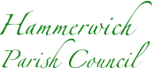](https://www.hammerwichparishcouncil.co.uk/)

**Road safety initiative goes digital, with Solar Powered equipment.**

Hammerwich Parish Council has recently invested in the latest digital Speed Indicator Devices (SID), charged by Solar Panels in a bid to make motorists aware of their speed travelling through the village.

The SID picks up the speed of the vehicle, and displays it clearly on an LED screen. If the speed is over the speed limit, a red angry face is displayed, if under the limit, a green smiley face is displayed.

Vance Wasdell, Chairman of Hammerwich Parish Council, remarked how impressed he was with the response shown by drivers, public participation is the key, and we seem to be getting it. ''I thank Cllr. Dave King for his hard work to make our roads safer''

Previously, a dedicated Speedwatch Team has been actively cooperating with Staffordshire Police, reporting speeders on a regular basis. This service will run alongside the SID initiative, in a drive to make our roads as safe as possible.

** ** 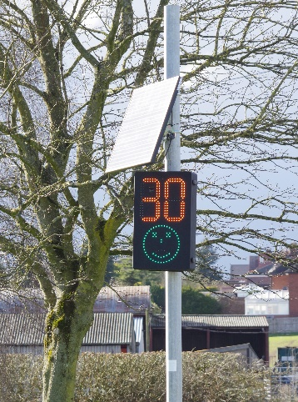

**Hammerwich Parish Council road safety initiative**